A

Project Report

On

**Library Management System**

Website Design

Submitted to

**SHIVAJI UNIVERSITY, KOLHAPUR**

For the partial fulfillment of the requirement for the award

**MASTER OF COMPUTER APPLICATIONS**

**(SEM –II)**

By

**Mr. Vidyasagar Balaso Patil**

Under the guidance of

**Prof. A. A. Govande**

Through

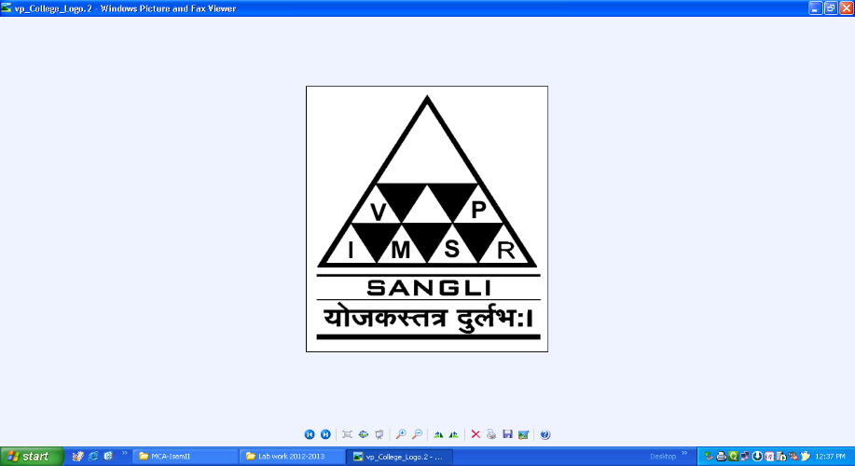

The Principal

**V. P. INSTITUTE OF MANAGEMENT STUDIES AND RESEARCH, SANGLI**

2022-23

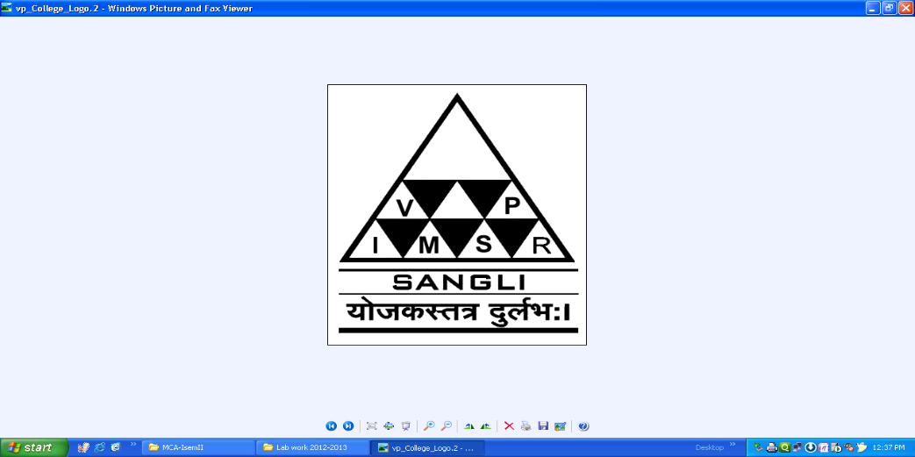

**V. P. Institute of Management Studies &**

**Research, Sangli- 416 414**

Certificate

**Department of Computer Applications**

This is to certify that, the project report entitled **Library Management System** is record of project work carried out in this college by **Mr. Vidyasagar Balaso Patil** in partial fulfillment of the award of Master of Computer Applications (Sem-II) as laid down by SHIVAJI UNIVERSITY, KOLHAPUR.

This project presents his sincere work carried out under my guidance in the year 2022-23.

Date:

Prof. A. A. Govande Dr. Ms. V. S. Jadhav

**Project Guide** **H.O.D.**

Examiner: 1) 2)

**DECLARATION**

To,

The Registrar,

Shivaji University, Kolhapur

Sir,

I undersigned **Patil Vidyasagar Balaso** hereby declare that, the project report entitled **Library Management System** submitted by me under the guidance of **Prof. A. A. Govande,** is my original work.

I have not reproduced any information from any report submitted to Shivaji University, Kolhapur this year or any of the previous years.

I understand that any such copying is liable to punish in a way that University Authorities deem fit.

Place: Sangli

Date:

Mr. Vidyasagar Balaso Patil .…………

**Acknowledgement**

I am very much thankful to **Hon. Principal Dr. R. A. Shinde Sir** for their encouragement, inspiration and also for providing facilities needed for the accomplishment of this course.

I would like to thank my faculty and also project guide **Prof. A. A. Govande** and **Dr. Ms. V. S. Jadhav** Head of Computer Department (V.P.I.M.S.R), for their valuable support.

Also I like to take opportunity to thank my all Computer faculties, administration and library staff for their support throughout the project.

Last but not least I would also thank my friends who have helped me directly and indirectly for successfully completing this project.

Place: Sangli

Date:

**Mr. Vidyasagar B. Patil**

**INDEX**

|  |  |  |
| --- | --- | --- |
| **Sr. No.** | **Contents** | **Page No.** |
| **1** | **Introduction to Project**  1.1] Introduction  1.2] Existing System  1.3] Need and scope of Computer System | 1 |
| **2** | **Proposed System**  2.1] Objectives  2.2] Requirement Engineering  • Requirement Gathering  • SRS | 2-4 |
| **3** | **System Analysis**  System Diagram  3.1] DFD  3.2] ERD  3.3] Site Map | 5-7 |
| **4** | **System Design**  4.1] Database Design  4.2] Input Design  4.3] Output Design | 8-20 |
| **5** | **Report** | 21-22 |
| **6** | **Conclusion and Suggestions**  7.1] Conclusion  7.2] Limitations  7.3] Suggestion | 23 |
| **7** | **References**   * Books * Web | 24 |
| **8** | **Annexure**   * Source code(Include Main Logic source code) | 25-32 |